AMIVO UNIVERSITY

**AMIVO REPORT**

**Kpi 1:** Retreive a list of all students

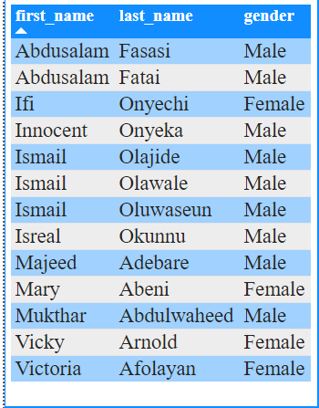

***Report:*** *The table above shows the list of all students in AMIVO University including their gender*

**Kpi 2:** Find the sum GPA of students by Gender

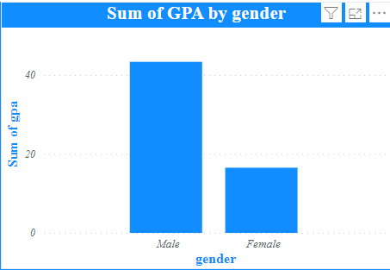

***Report:*** *Sum of gpa for Male (43.30) was higher than Female (16.50).﻿ ﻿Male accounted for 72.41% of Sum of gpa. Male had 43.30 Sum of gpa and Female had 16.50.*

**Kpi 3:** Find the average GPA of students for a particular department

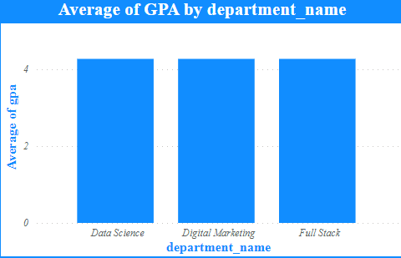

***Report:*** *﻿At 4.60, Data Science had the highest Average of gpa and was 27.78% higher than Digital Marketing, which had the lowest Average of gpa at 3.60. Data Science had the highest Average of gpa at 4.60, followed by Full Stack, , and Digital Marketing. Across all 4 department_name, Average of gpa ranged from 3.60 to 4.60.*

**Kpi 4:** Get the names of student on first class GPA

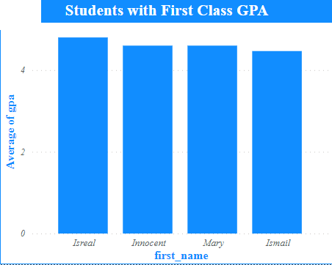

***Report:*** *﻿* *﻿At 4.80, Isreal had the highest Average of gpa and was 7.46% higher than Ismail, which had the lowest Average of gpa at 4.47. Isreal had the highest Average of gpa at 4.80 and Ismail had the lowest at 4.47. Across all 4 first_name, Average of gpa ranged from 4.47 to 4.80.*

**Kpi 4:** Get the number of student offering a Machine Learning

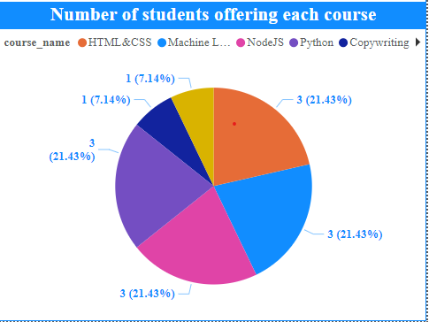

***Report:*** *﻿* *﻿Only a student is offering machine learning which is* ***Abdusalam Fatai***

**Kpi 5:** create a list of lecturers with their specified courses

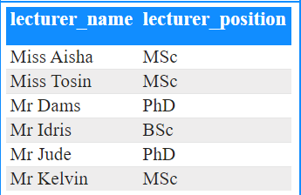

***Report:*** *﻿ The table above shows the list of all lecturers in AMIVO University including their position*